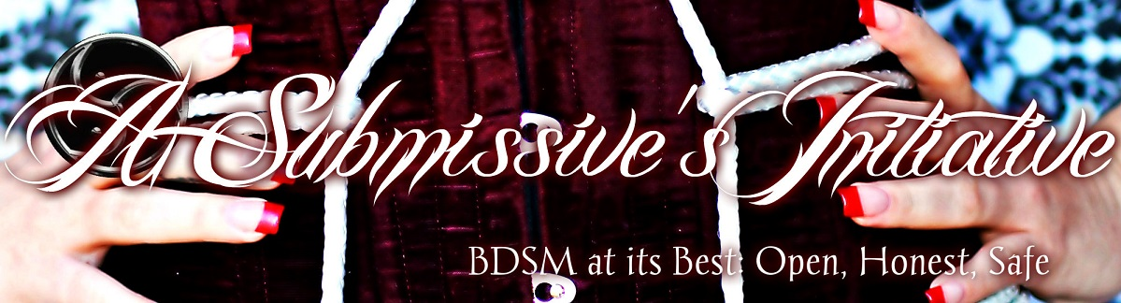
A Submissive’s Initiative BDSM Checklist
Use this checklist to either gauge your own interests or sit down and go over it with your partner and discuss each topic together. This is also a great way to talk about your fetishes, laugh a little and a learn a lot about your partner! The BDSM Checklist is an excellent “ice breaker” for introducing BDSM into your relationship.
For each activity, there are three answers.
The first answer should be, if you’ve ever tried that activity before
- Yes = I have participated in this activity before
- No = I have not participated in this activity before

The second answer should be your interest in engaging in that activity on a scale of 0 – 5.
- 0 = I have no interest/don’t like this.
- 1 = Not very interesting/don’t really enjoy this too much.
- 2 = This is alright.
- 3 = This is nice/fun/interesting
- 4 = I really enjoy/think I’ll enjoy this activity
- 5 = I LOVE THIS/CAN’T WAIT TO TRY THIS

The third Answer would be to write any explanations or more information after your answers. Remember, the more information you have the safer/hotter/more fun things will be.
Examples:
Flogging: Yes/5 - I especially love to be flogged on my back!!!
Tickling: Yes/5 - My feet are my most ticklish place but I didn’t tell you that!

SEX:
Anal Sex:
Armpit Sex:
Ass Cheek Sex:
Butt Plugs:
Dildo – Anal:
Dildo – Oral:
Finger Sex:
Genital Intercourse:
Hand Job:
Including others:
Licking:
Licking:
Massage:
Oral Sex:
Phone Sex:
Sex in Public:
Sex Outdoors:
Swinging:
Teasing:
Vibrators:
BONDAGE:
Blindfolds:
Body Bags:
Bondage – full body:
Bondage – Intricate Rope:
Bondage – Mental:
Bondage – Outdoors:
Bondage – Private:
Bondage – Public:
Boxing / Closeting:
Caging:
Cock Bondage:
Crucifixion:
Cuffs Leather:
Cuffs Metal:
Duct Tape:
Full Head Hoods:
Gags – ball type:
Gags – bits:
Gags – cloth:
Gags – inflatable:
Gags – phallic:
Gags – tap:
Gas Masks:
Gates of Hell:
Harnessing – leather:
Harnessing – rope:
Headphone/Earplugs:
Masks:
Mummification:
Padlocks:
Plastic Wrap:
Restraint Duration: 1-3hrs:
Restraint Duration: 3+ hrs:
Restraint Duration: multiple days:
Restraint Duration: overnight/full day:
Restraint in public – under clothes:
Restraints – Ankle:
Restraints – Arm leg sleeves:
Restraints – Hand Cuffs:
Restraints – Leather:
Restraints – Metal:
Restraints – Rope:
Restraints – Thumb Cuffs:
Restraints – Wrist:
Restraints – Wrist to ankle/neck/waist:
Silk Scarves:
Sleepsacks:
Slings/Swings:
Spreader bars:
Stethescope:
Stocks:
St. Andrews Cross:
Straight Jackets:
Suspension:
Suspension – Horizontal:
Suspension – Inverted:
S&M:
Abrasion:
Anal Dilation:
Anal Fisting:
Asphyxiation:
Bastinado:
Beating – hard:
Beating – soft:
Belt/Strap:
Biting:
Caning:
Choking:
Clothespins:
Cock and Ball Torture:
Cupping/Suction:
Cutting:
Electricity – Tens Unit:
Electricity – Violet Wand:
Face Slapping:
Fireplay:
Flogging:
Hair pulling:
Hairbrushes:
Hot Oils:
Ice Cubes:
Injections:
Nipple Clamps:
Nipple Torture:
Nipple Weights:
Paddling:
Piercing – temp:
Pinching:
Punching:
Riding Crops:
Scratching:
Spanking – on all fours:
Spanking – over knee:
Spanking hard:
Spanking soft:
Strapping – Full Body:
Urethral Sounds:
Whipping – buggywhip:
Whipping – bullwhip:
Whipping – Cat:
Whipping – genitals:
Whipping – knotted whip:
Whipping – Quirt:
Whipping – Signal Whip:
Whipping – switch:
Whipping – Taws:
FETISH:
Abandonment:
Acrophilia:
Acrotomophilia:
Agalmatophilia:
Barosmia:
Being Recorded:
Bestiality:
Bestiality:
Body Worship:
Boot Worship:
Branding:
Brown Showers:
Brown Showers:
Castration Fantasy:
Catheterization:
Chamber Pots (use):
Cock Rings:
Cock Rings:
Corsets:
Corsets:
Cross-Dressing:
Cross-Dressing:
Diapers:
Dirty Sex:
Douching:
Enemas:
Erotic Dancing:
Exhibitionism:
Fear:
Feathers/Fur:
Feathers/Fur:
Foot Worship:
Golden Showers:
Gun Play:
High Heel Worship:
Humiliation:
Infantilism:
Latex:
Latex:
Leather:
Leather:
Lingerie:
Lingerie:
Medical Instruments:
Needles:
Oral/Anal Play:
Pain:
Piercing (Permanent):
Posing for Erotic Photos:
Prostitution (real):
Public Exposure:
PVC:
PVC:
Recording Scenes:
Rituals:
Shaving:
Skinny-Dipping:
Sensory Deprivation
Spandex:
Spandex:
Speculums (anal):
Spitting:
Supplying victims:
Swallowing Semen:
Taking Erotic Photos:
Tasting Yourself:
Tattoo:
Tattoos:
Tickling:
Uniforms:
Uniforms:
Voyeurism:
Wearing Fluids:
Wrestling:
POWER PLAY:
Bathroom use control:
Begging:
Behavior Restrictive Rules:
Butt Plugs – public:
Chastity Belts:
Clothing choice:
Cock Worship:
Collar and Leash:
Collars:
Competition:
Crawling:
Eye Contact Restriction:
Following Orders:
Food Choice/Directed Eating:
Forced Dressing:
Forced Exercise:
Forced Homosexuality:
Forced Masturbation:
Forced Nudity:
Forced Servitude:
Given Away:
Hot or Sensual Waxing:
Housework:
Humiliation – Private:
Humiliation – Public:
Humiliation – Verbal:
Kneeling:
Lecturing:
Manicures:
Manicures:
Name Change:
Orgasm Control:
Orgasm Denial:
Personality Modification:
Pussy Worship:
Serving Orally:
Sexual Deprivation:
Sleep Deprivation:
Speech Restrictions:
Standing in Corner:
Struggling:
Symbolic Jewelry:
Weight Gain/Loss:
ROLE PLAY:
Chauffeuring:
Fantasy Gang Rape:
Fantasy Rape:
Initiation Rites:
Interrogations:
Kidnapping:
Medical Scenes:
Other Animal Play:
Physical Examinations:
Pony Play:
Prison Scenes:
Prostitution (pretend):
Punishment Scene:
Puppy Play:
Religious Scenes:

Schoolroom Scenes:
Serving as Art:
Serving as Ashtray:
Serving as Furniture:
Serving as Maid:
Strap on Dildos:

Important Questions:

Do you have any mental health issues that would impair or hinder a scene?

Do you have any physical health issues that would impair or hinder a scene?

Do you have any fears or limitations that would impair or hinder a scene?

